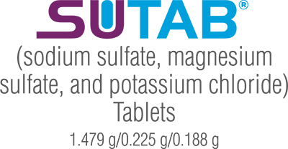

How to Prep for Your Upcoming Colonoscopy

On the Day Before Your Procedure

What You CAN Do
- You may have low residue breakfast and lunch (no solids after noon).
- You may have clear liquids

What You CANNOT Do
- Do not drink milk or eat or drink anything colored red, orange or purple
- Do not drink alcohol
- Do not take other laxatives while taking SUTAB
- Do not take oral medications within 1 hour of starting each dose of SUTAB
- If taking tetracycline or fluoroquinolone antibiotics, iron, digoxin, chlorpromazine, or penicillamine, take these medications at least 2 hours before and not less than 6 hours after administration of each dose of SUTAB.

Liquids That Are OK to Drink
- Coffee or tea (no cream or nondairy creamer)
- Fruit juices (without pulp)
- Gelatin desserts (no fruit or topping) (no red, purple, or orange)
- Water
- Power Aid or Gatorade (no red, purple, or orange)
- Chicken broth
- Clear soda (such as ginger ale, Sprite or 7-Up)

The Dosing Regimen
SUTAB is a split-dose (2-day) regimen. A total of 24 tablets is required for complete preparation for colonoscopy. You will take the tablets in two doses of 12 tablets each. Water must be consumed with each dose of SUTAB, and additional water must be consumed after each dose.

DOSE 1 – On the Day Prior to Colonoscopy

Take the tablets with water ONLY and then can have other clear liquids such as apple juice, Gatorade or Power Aid (no red, orange, or purple)
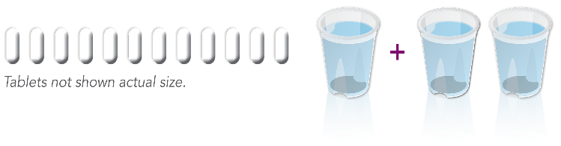
STEP 1 At 5:00-6:00 P.M. Open 1 bottle of 12 tablets.
STEP 2 Fill the provided container with 16 ounces of water (up to the fill line). Swallow each tablet with a sip of water, and drink the entire amount of water over 30-60 minutes.
IMPORTANT: If you experience preparation-related symptoms (for example, nausea, bloating, or cramping), pause or slow the rate of drinking the additional water until your symptoms diminish.

Drink additional water, or clear liquids
STEP 3 Approximately 1 hour after the last tablet is ingested, fill the provided container again with 16 ounces of clear liquid of choice (up to the fill line), and drink the entire amount over 30 minutes.
STEP 4 Approximately 30 minutes after finishing the second container of clear liquids, fill the provided container with an additional 16 ounces of clear liquid of choice (up to the fill line), and drink the entire amount over 30 minutes.

On the Day of Your Procedure

DOSE 2 – Day of the Colonoscopy
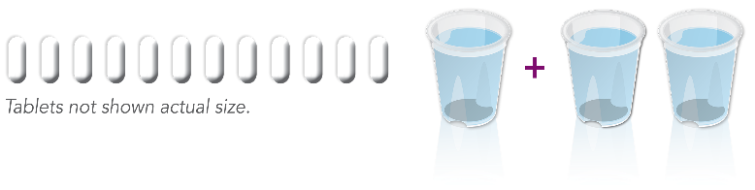
- Continue to consume only clear liquids but STOP
all liquids 2 HOURS before colonoscopy
- The morning of the colonoscopy at _________A.M.
(6 hours prior to the colonoscopy plus driving time), open the second bottle of 12 tablets
- Repeat STEP 1 to STEP 4 from DOSE 1

IMPORTANT: You must complete all SUTAB tablets and required water at least 2 hours before colonoscopy.
You will need to arrange for a ride home after the procedure from a friend or family member. We do not allow rides from public transportation due to concerns for your safety.

